CS-322 Software Construction

SRS DOCUMENT:( finance tracking system)


Project Management System

PRESENTED BY

GROUP NO(G17)
MEMBER 1:BIBI RABBIA (GROUP LEADER)
MEMBER 2 :HUMAIRA NADEEM (ABSENT)
MEMBER 3:FATIMA ANUM(ABSENT)
USE C ASE :
Bibi rabbia(user authentication ,edit/delete transaction,view report)
Fatima anum(add category,add transaction ,add savings)
Humaira Nadeem(view transaction history,view graph,modified savings)

SUPERVISED BY
Dr. Onaiza Maqbool

Department of Computer Science
Quaid-e-Azam University, Islamabad
Project Plan Document Approval Signatures
Project Manager
______________________ _______________________
Signature Date

Bibi rabbia
Student, QAU Islamabad
Member 1
______________________ _______________________
Signature Date

Humaira nadeem
Student, QAU Islamabad
Member 2
______________________ _______________________
Signature Date

Fatima anum
Student, QAU Islamabad

Member 2
______________________ _______________________
Signature Date

Dr. Onaiza Maqbool
Professor, QAU Islamabad

- USE CASES (DESCRIPTION)
- FR-1: User Authentication(bibi rabbia)
- Actor: User
- Pre-Conditions:
- The application must be installed and running.
- For login, the user must already have a registered account.
- Post-Conditions:
- A new user account is created or
- The user is successfully logged in/logged out.
- Main Success Scenario:
- The user opens the application.
- The user selects "Create Account."
- The user enters personal details.
- The system validates information.
- The system creates the account.
- The user enters login credentials.
- The system verifies the credentials.
- The user is granted access to the system dashboard.
- Alternative Flows:
- A1: Invalid Registration Information
- The system detects missing/incorrect fields and shows an error.
- A2: Incorrect Login Credentials
- The system displays “Invalid username or password”.
- Inputs: Personal details (name, email/username, password) for registration; login credentials (username/email, password)
- Outputs: "Account created successfully" message; dashboard displayed after login; error messages ("Invalid username or password" / missing or incorrect fields error)

USE CASE:2
ADD TRANSCATION :(Fatima anum)
Actor: User
Pre-Conditions:
- The user must be logged in.
- At least one category must be available for selection.
Post-Conditions:
- The transaction is stored in the database.
- The total balance is updated accordingly.
Main Success Scenario:
- The user selects “Add Transaction.”
- The user chooses the transaction type (Income/Expense).
- The user enters the amount.
- The user selects a category.
- The user enters or selects the transaction date.
- The system validates the entered information.
- The system saves the transaction.
- The system updates the total balance.
- The system displays a confirmation message.
Alternative Flows:
- A1: Invalid Amount
  - The system displays an error message and asks the user to enter a valid amount.
- A2: Category Not Selected
  - The system asks the user to select a category.
- A3: Invalid or Missing Date
  - The system displays an error message and asks the user to enter a valid date.
- A4: Invalid Transaction Information
  - The system rejects the transaction and asks the user to correct the entered information.
Input/Output
Input:
- Transaction Type
- Amount
- Category
- Date
Output:
- Transaction saved confirmation
- Updated total balance

USE CASE 3:(bibi rabbia)
EDIT/DELETE TRANACTION:
(system sequence diagram):

UC 3

USE CASE 4:ADD CATEGORY(Fatima anum)
(system sequence diagram)

USE CASE 5:ADD SAVINGS:(Fatima anum)
Sequence diagram
USE CASE 6:VIEW GRAPH:(humaira Nadeem)
System sequence diagram

USE CASE 7 :VIEW TRANSACTION HISTORY:(humaira Nadeem)
SYSTEM SEQUENCE DIAGRAM

USE CASE 8:MODIFIED SAVING:(humaira namdeem)
System sequence diagram

USE CASE 9:VIEW REPORTS:(bibi rabbia)
Actor: User
Pre-Conditions:
- The user must be logged in.
- At least one transaction must exist in the system.
Post-Conditions:
- The selected financial report is displayed to the user.
- The system data remains unchanged.
Main Success Scenario:
- The user selects the "View Reports" option.
- The user chooses a reporting period (Weekly, Monthly, or Yearly).
- The system retrieves the financial data for the selected period.
- The system generates the report based on that data.
- The system displays the report to the user.
Alternative Flows:
- A1: No Records Available
  - If there are no transactions in the selected period, the system displays the message "No data available."
- A2: Report Generation Failed
  - If the system cannot generate the report, it shows an error message and asks the user to try again.
Inputs:
- Reporting period ( Monthly )
Outputs:
- Financial report (total income, total expenses, savings, and category-wise summary; add a graph if your system shows one)
- The message "No data available" or an error message if the report cannot be generated

Use case 3:edit/delete transaction :
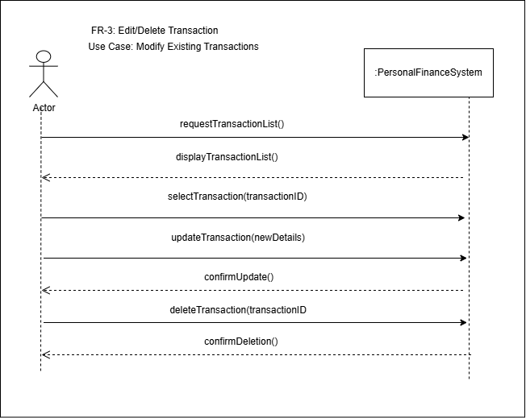

USE CASE 4:add category:
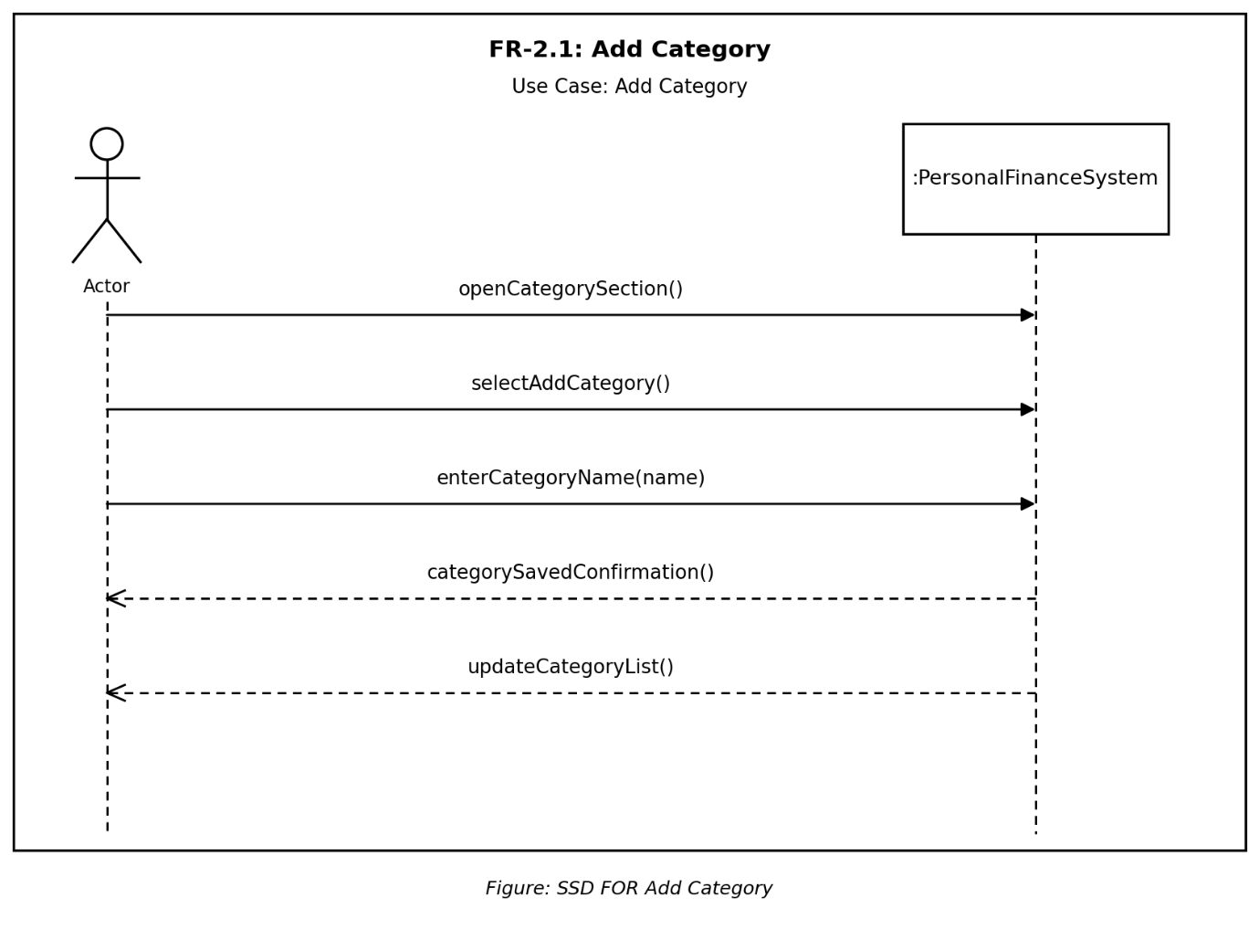

Use case 5: add savings
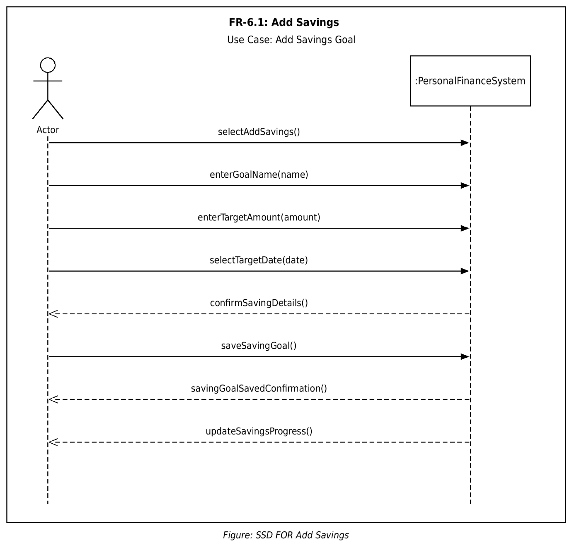

Use case 6:
View graph:
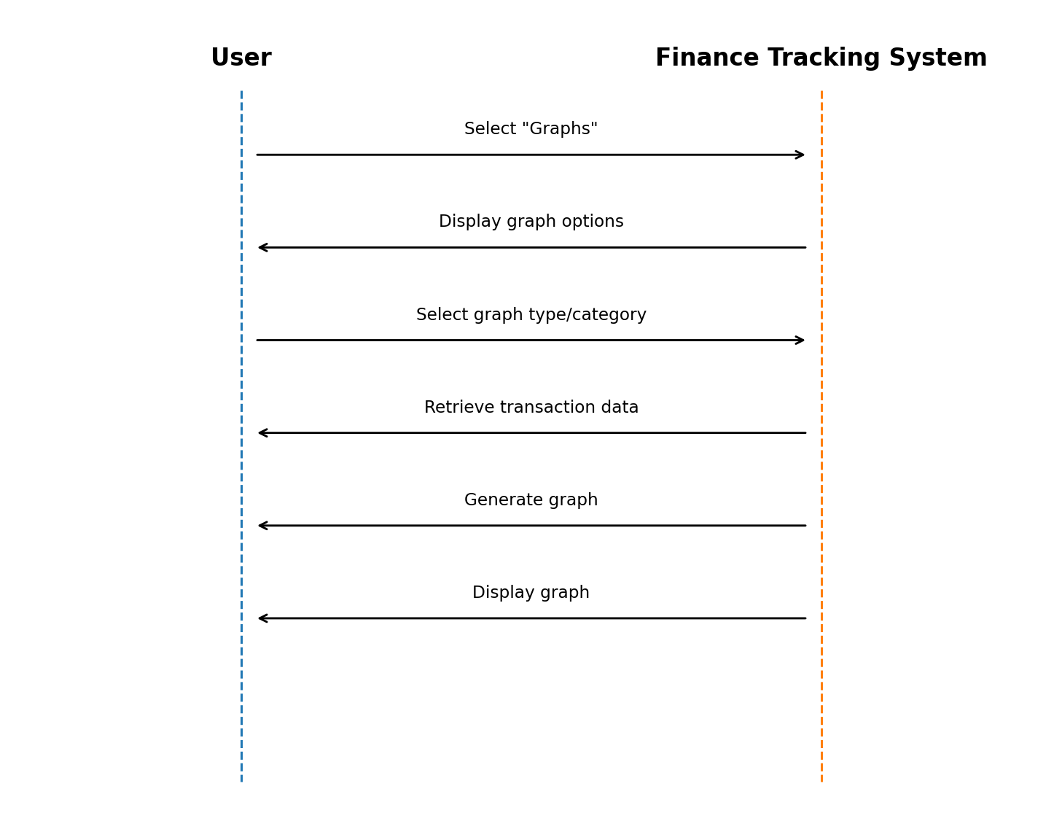

USE CASE 7:VIEW TRANSACTION HISTORY
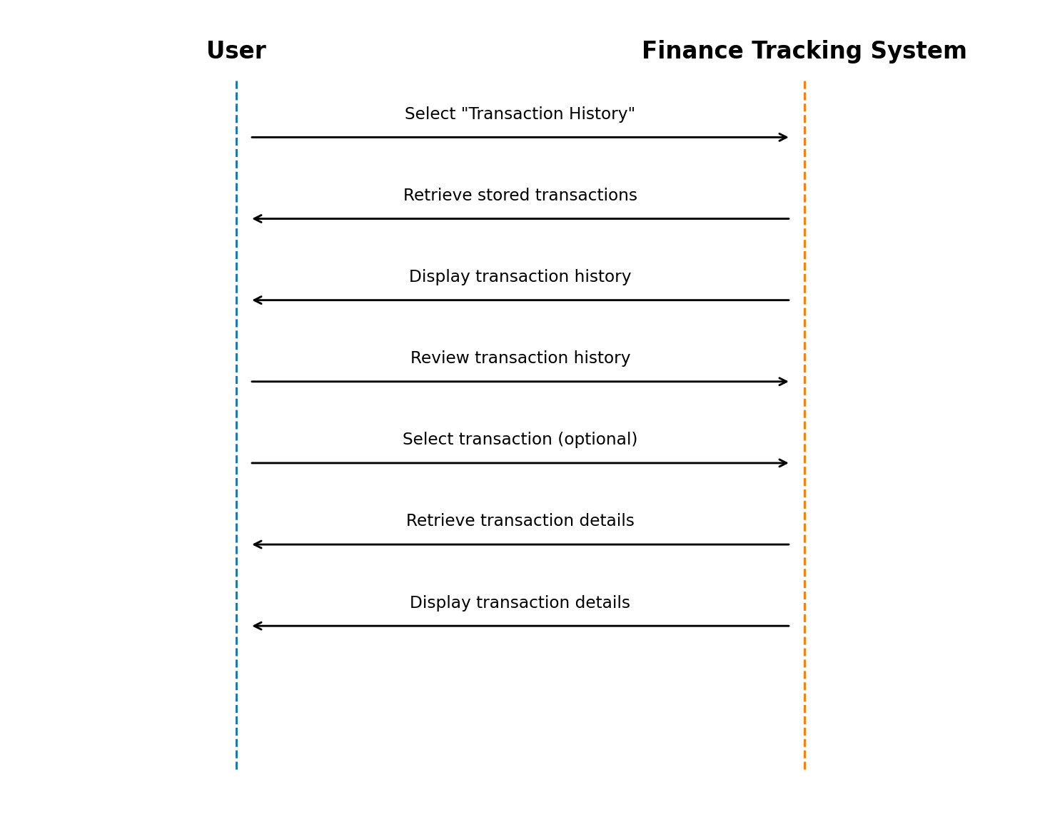

Use case 8:modify savings:
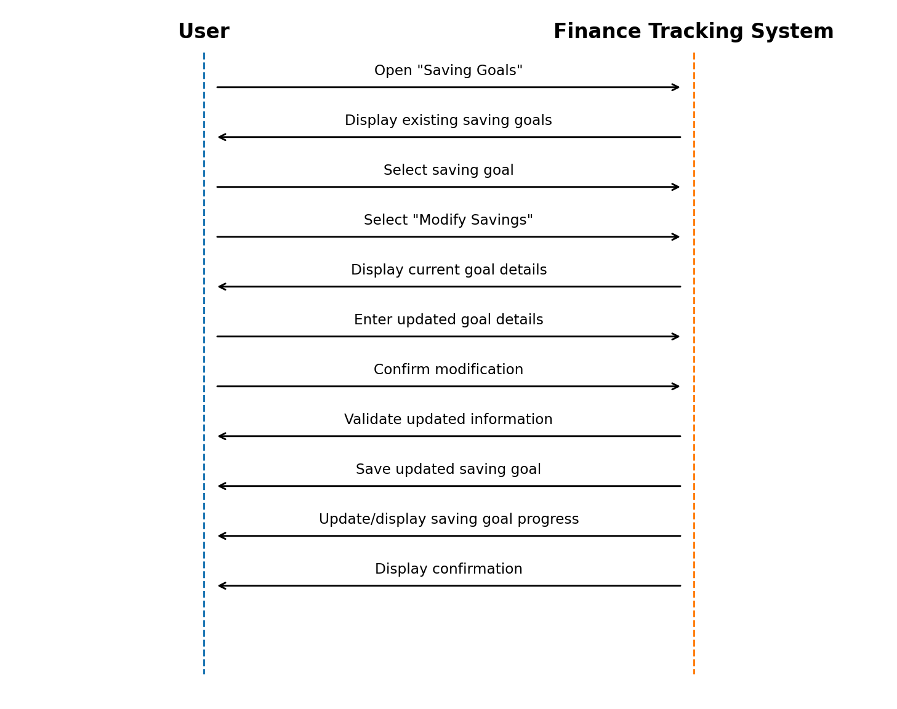

Domain Model:
